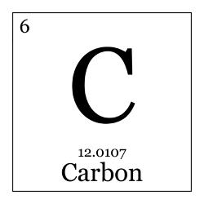
Medical Interventions “Education is the most powerful
Ms. weapon which you can use to change
isneros the world.” –Nelson Mandela

River City High School | E-mail: ccisneros@wusd.k12.ca.us | Telephone: ext. 2703
THE COURSE: Medical Interventions is Year 3 of the four-year Project Lead the Way Biomedical Science curriculum. Students should have already passed Year 1 (Principles of Biomedical Science) and Year 2 (Human Body Systems).
OVERVIEW: Students investigate the variety of interventions involved in the prevention, diagnosis and treatment of disease as they follow the lives of a fictitious family. The course is a “How-To” manual for maintaining overall health and homeostasis in the body as students explore:
- How to prevent and fight infection
- How to screen and evaluate the code in human DNA
- How to prevent, diagnose and treat cancer
- How to prevail when the organs of the body begin to fail.
Through these scenarios, students are exposed to the wide range of interventions related to immunology, surgery, genetics, pharmacology, medical devices, and diagnostics. Lifestyle choices and preventive measures are emphasized throughout the course as well as the important roles scientific thinking and engineering design play in the development of interventions of the future.
Units:
- How to Fight Infection 3. How to Prevail When Organs Fail
- How to Screen What Is In Your Genes 4. How to Conquer Cancer
Recommended Materials: Optional Supportive Materials:
- Composition Notebook 1. Post-it notes
- Writing Devices: Pencils 2. Index Cards
- Highlighter (any color)
Grading:
Notebook/Assignments | 20% of grade | Portfolio | 10% of grade |
Assessments | 30% of grade | Participation | 10% of grade |
Lab Reports/Projects | 30% of grade |
Grading Scale:
90% to 100% = A
80% to 89% = B
70% to 79% = C
Cord Requirements:
In order to receive a graduation cord, ALL FOUR CLASSES must be complete with a grade of C or better in each.
What else should I know about this class?
- Guest Speakers: We are always looking for guest speakers with careers related to any type of healthcare career! Please contact me if you have anyone that you think might be interested in sharing their expertise with us
- Digital Portfolio (Google Drive): You are required to have 3 projects in your portfolio, 1 will be your ELISA lab and you will choose 2 other projects at your leisure. You must write a reflection and take Pictures!

Classroom Rules:
- ALL RCHS rules must be followed.
- Come PREPARED to class each day: bring your pens, pencils, notebook, and paper.
- No food or beverage consumption in the lab areas.
- The bell does not dismiss you.
- Be in the room before the tardy bell rings or you will be marked tardy.
- NO electronics to be used in class unless instructed to do so. Electronics will be taken away and other measures will be taken. If I see it, I take it!
- Backpacks and purses are to remain off the desks at all times.
- Classroom agreements must be followed.
- Laboratory contract must be signed and followed.
If any of the above rules are broken, further consequences will be taken such as: call home, seat change, etc.
Absences:
If you are absent, it is your responsibility to complete all the make-up work:
- Assignment worksheets are placed in the classroom, you are welcome to collect them before or after class.
- Make-up for missed quizzes and tests will be given before school or during lunch the day the student returns. Please discuss lab make-ups with Ms. C. AFTER ONE WEEK: 50% MAX of points.
Late-work:
Once an assignment is not turned-in on time, each day decreases the maximum point value the student can receive by 10%.

One day late = Max 90% Three days late = Max 70% WEEKENDS
Two days late = Max 80% Four days late = Max 60% ARE
Three days late = Max 70% After five days, Max 50% INCLUDED!
NOTEBOOKS WILL NOT BE COLLECTED FOR NOTEBOOK CHECK PAST 1 week of the due date!
Homework Reminder Sign-up (for students and guardians/parents):
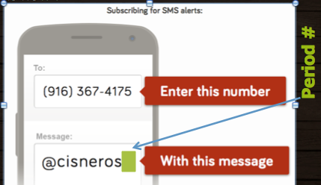
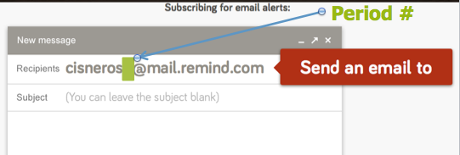

81010

Keep in mind….
I believe that each and every one of you has the capacity to succeed and strive in this course. I am here for you before & after school as well as lunch time for any support you may need. Please let me know as soon as possible if you need any accommodations.
I’ll see you all on back to school night
-Ms. Cisneros
Student Signature:_________________________________________________________

Parent/Guardian Signature:__________________________________________________

